# A Practicum Task Review Report

# Submitted on May 07, 2017, to the

# Department of Data Science of the

# College of Computer & Information Sciences

# Regis University

# in partial fulfillment of the requirements for a

# Master of Science in Database Technology

# By

# Rohan Purohit, Chad Spencer, Daniel Banta, Thomas Dube II, Jimmy Pham, Mohammad Alzahrani, Hanan Hazazi

# Database Practicum Project Advisor

# Bob Mason, Ph.D. Table of Contents

[Table of Contents ii](#_Toc286694429)

[Chapter 1 - Introduction 3](#_Toc286694432)

[Chapter 2 – Practicum I Tasks 4](#_Toc286694448)

[Chapter 3 – Practicum II Tasks 16](#_Toc286694448)  
[Chapter 4 – CONCLUSION](#_Toc286694448) 20

# Chapter 1 - Introduction

**Overview**

The MSCD692 and MSCD696 - Database Practicum courses satisfy the Graduate Final Project requirement for graduation from the Master of Science in Database Technologies program, with a total of 36 credit hours of course work required to graduate

The goal of the Database Practicum project is to facilitate a real-life, hands-on learning experience via the development of functional software, and we were able to get hands on experience with multiple applications, including Linux, OEM and Oracle Apex. Between creating and maintaining databases for Regis students, and getting experience creating an app with server based applications, the team was exposed to various database elements to help prepare us for the DBA world.

**Deliverables**

# Each DB Practicum participant will:

# • Provide documentation of various stages of their labs, showing their understanding and accomplishments. Each task has its own documentation requirements such as screenshots, written responses, or online admin setup so the professor can view.

# • Provide two types of final reports that will document the accomplishments of the team - one consolidated team report, and a series of individual reports from each team member that has only the accomplishments of the individual. We each made our individual reports first, then combined various elements for the overall group report. Chapter 2 – Practicum I Tasks

**Project Organization: Regis SharePoint**

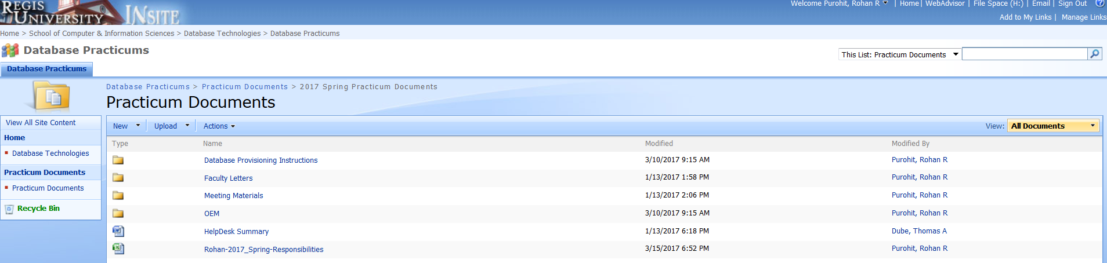At the beginning of the Practicum I, Rohan created the SharePoint structure, which helped us remain organized, and allowed us to document our work.

**Linux and Solaris Recipes for Oracle DBAs**

Our first task in Practicum I was to become familiar with common Linux commands. Darl Kuhn’s *Linux and Solaris Recipes for Oracle DBAs* was referenced to get a background on server administration. We were able to log on to the **ora05.regis.net** Red Hat Linux server on Citrix and use Putty to practice commands, then modify and execute scripts.

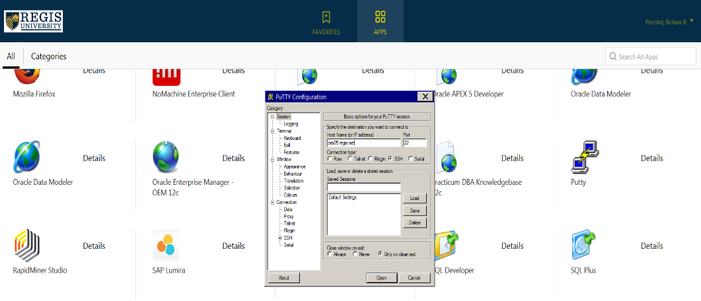

Linux User Commands

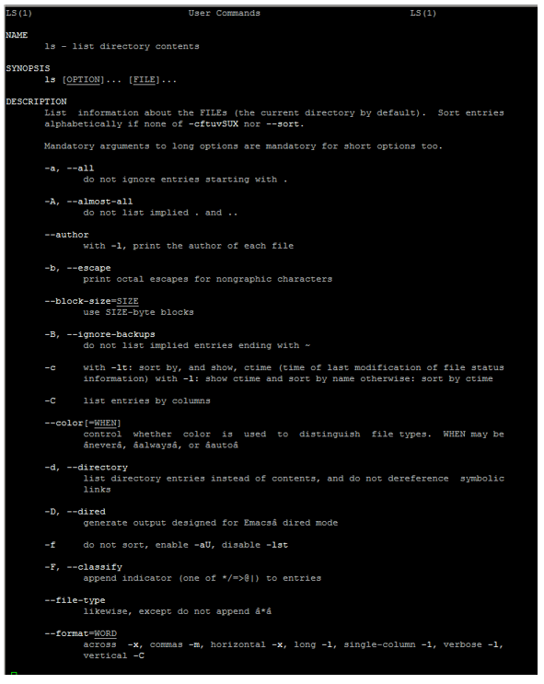

After practicing the Linux commands, we navigated the Linux server and used vi text editor to edit scripts. Once the script was edited, we changed permissions using chmod777 and executed the scripts to create database objects.

# 

**APEX LAB OBJECT CREATION**

Sample of scripts used to create and manage the user IDs

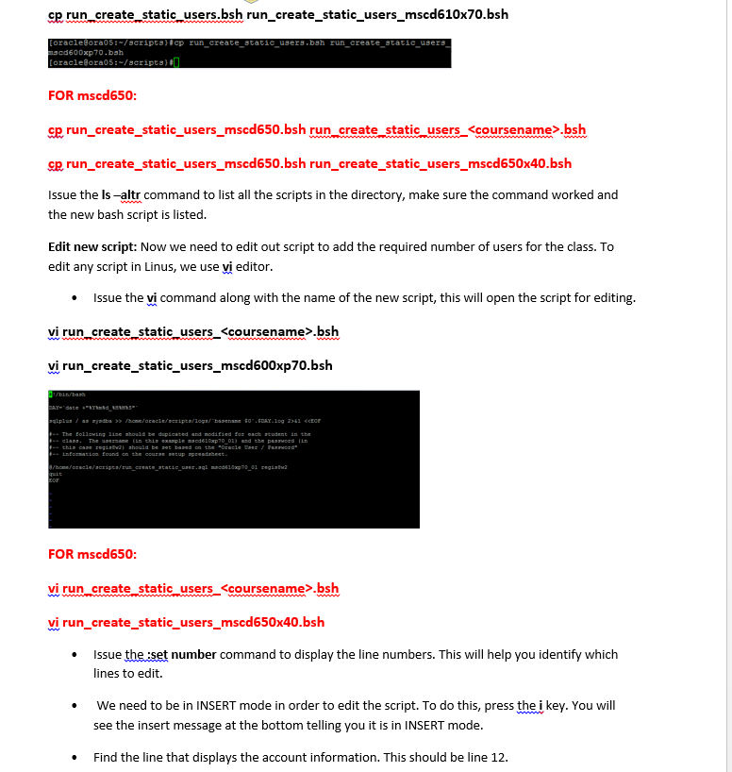

# Deleting Old Databases

The practicum was tasked with a list of obsolete databases that needed to be removed from the server. The task can be simple if the database can open and run with the users and passwords available to us. The task is more complicated if the database is unwilling to open; in which case, we must delete the database files from the various places in the directory structure. Furthermore, the location of those database files may not fall in the Oracle’s Optimal Flexible Architecture (OFA). Tom found that Regis modified the location of the file architecture slightly to support the many updates and Oracle binaries installed on the server.

Machine generated alternative text:
ORACLE. HOME 
NCLE_BASE 
. profile 
(inat parameter) 
Conten tsXML 
12.10 
(version) 
checkpoints 
dbname 1 
diag 
admil 
binaries oracle, sqlplus, 
sterrr.ora 
admin 
sqlnet ora 
TNS_ADMIN 
or inn.ora 
orapW pwd file 
um 
log info (Old databases) 
12c inh 
log_archive dest_ N 
Fast Ra»very FM) 
(in' t puameer) 
backwset 
datafile 
orheko 
contrglfile 
flash ENKk 
datafiles. online redo bgs. control"es: 
.cbt. reo%bg. 
_w_oo 
image copy 
file 
_w_DD 

Figure 1: Oracle’s OFA (Optimal Flexible Architecture) Standard

## Manual Deletion Instruction Assistance

The locations of the files for the databases on the server were researched using Linux commands. An Oracle Instance is made up of a few files: database files (\*.dbf and \*.ctl) database file system (dbump, cdump, arch and pfile) (Kuhn, 2013). The Database is also reported to the server in the listener.ora and the tnsnames.ora files. These files need to be backed up and edited to remove the databases. Tom helped provide the locations of these files on the server.

Remove

-----------------

1) regisapex

2) regisdb

3) regiscdb

12) m64401

5) mscd640cdbs

7) regis12cncdb

8) mscd642cdb

Keep

-------------------

13) apexdb12c

4) regisdb12c

6) regisapex12

9) oem12c

Figure 2: Delete Database list

## 

## Recover Space after Removing MSCD640

Every database that was created on the MSCD640 database was found to be a complete loss and needed to be removed from the server. Erik Holm provided some tips on how to look for the databases created by MSCD640, and based on the OFA, many abandoned databases could be located, including other databases besides MSCD640.

[oracle@oraOS —h 
File system 
Size Used Avail Use* 
/ de v 'mappe r /VoI Group O O —LogVoI O O 
/ dev/ sda3 
tmpfs 
[oracle@oraOS : 
3.51 
92M 
63G 
2.2T 
17M 
9.4G 
1.2T 
71M 
S4G 
Mounted on 
/ boot 
/ dev / shm 

**Oracle APEX Labs**

For Oracle APEX labs, we created workspaces. Once each workspace was created, tables were able to be created. Data was then uploaded to the table using SQL loader, with master and detail pages created to dynamically present a subset of the data in a custom view.

One of our workspaces:  
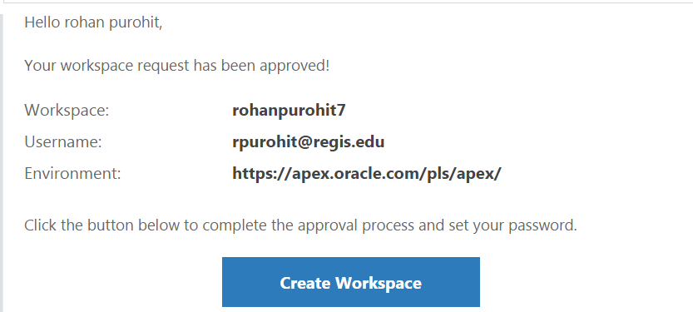

We created objects indicated in the Apex lab, and created a workspace with an admin user created for Professor Moore.

ONLINE APEX WORKSPACE NAME: APEX\_TRAINING\_HHAZAZI

APEX USERNAME WITH ADMIN RIGHTS (default is jeff): jeff

APEX PASSWORD FOR THE ABOVE ENVIRONMENT: jeff

For Apex Lab 2, we learned:

* Accessing database objects with page objects
* Use of authentication
* Use of conditional logic for page objects (or pages)
* Page creation including master/detail, form pages and report pages.
* Reports including report creation, alteration and value passing
* Use of PL/SQL Scripts and packages within APEX pages

We created an APEX application from the database tables created in Lab 1, with this application tested on apex.oracle.com, and working correctly.

# We also learned about some differences between MS SQL Server and Oracle in this lab, as well as some differences between SQL and PL/SQL, such as how they handle variables, stored procedures, and built-in functions.

**SQL Server Labs**

For the SQL Server labs, we installed SQL server and SQL Server Management Studio. We were then able to create tables, insert data, query data, create users, grant privileges to users, create views and delete database objects.

# Creation of a table

**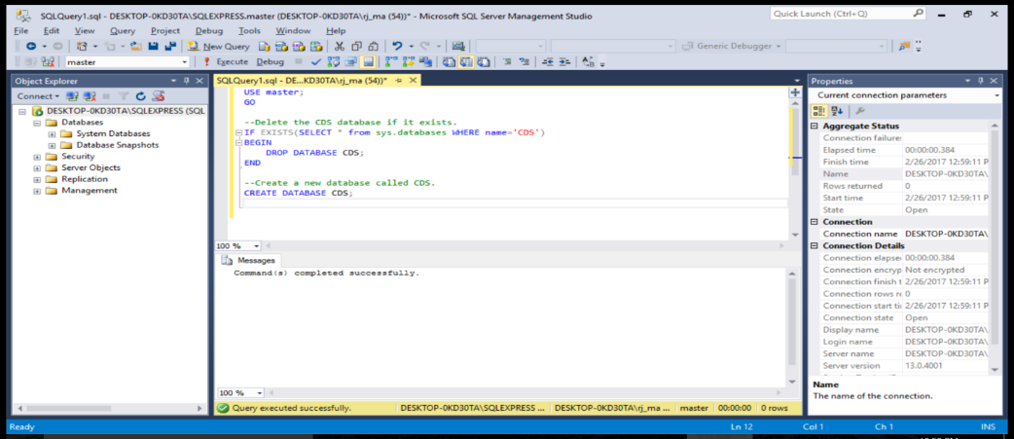**

Insertion and updating of table

**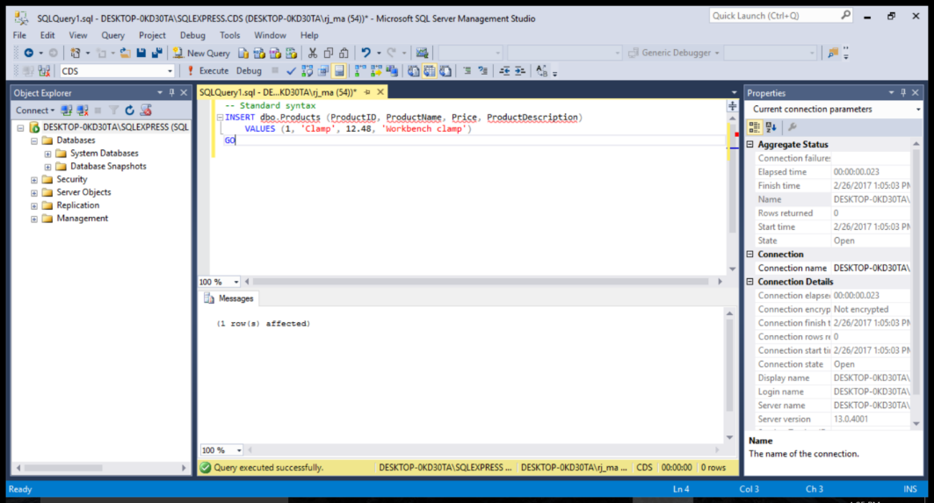**

Granted access to table

**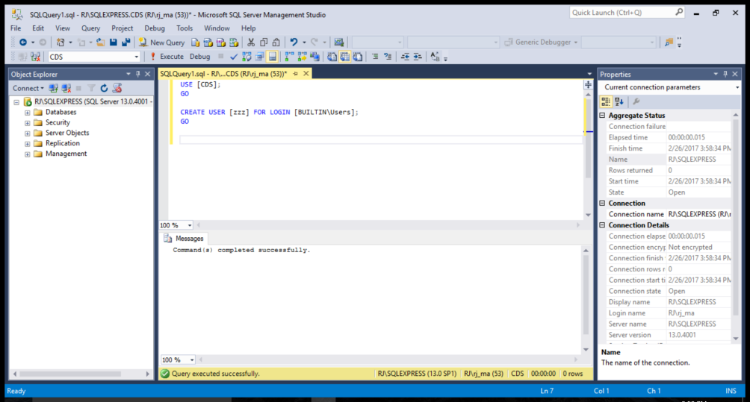**

**OEM Labs**

Our Oracle Enterprise Manager (OEM) lab allowed us to create a monitoring user account for a target database, and monitor the database related usage metrics visually using the enterprise manager dashboard.

The first step is to startup the OEM12C database, and we see that the startup does not work.



The SQL startup command looks for the **initoem12c.ora** file located with the 12.1.0 path, but the backup **init.ora.0302016132259** shows that the database files for the oem12c database reside in the 11.2.0 path. Tom went to the tnsname.ora and found that the HOST name in the tnsname.ora had (HOST = ora05), which he edited in vi.   
  
tnsname.ora now looks like this…

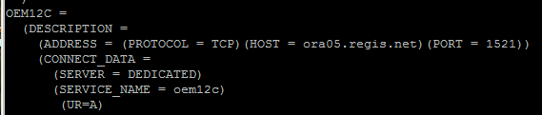.

The listener.ora was then corrected so the database name reads oem12c.

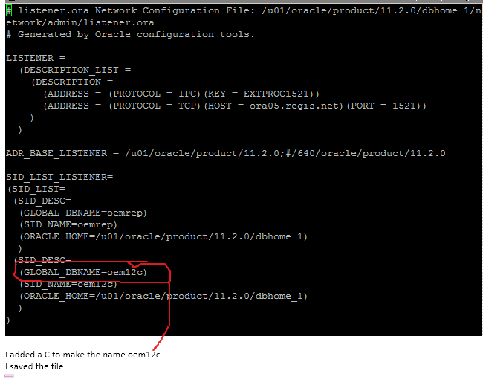.

Rohan was then able to coordinate with Upendra to get the OEM repository database and agent running. The team then went onto OEM together, with Dan logging on and sharing his screen in Skype. We worked through the instructions together, and started by adding targets. We added these targets to OEM by going to Agent based targets, and picking the **MSCD642cdbA30** database to promote.

We then logged onto Putty as a sysdba, started the database up, and checked the status.

The database was expired and locked so we alter user to open the account, and used the password “abc”. We returned to OEM to configure the database as a target, entered the ‘abc’ password into the monitor password section, and tested the connection successfully.  
OEM  
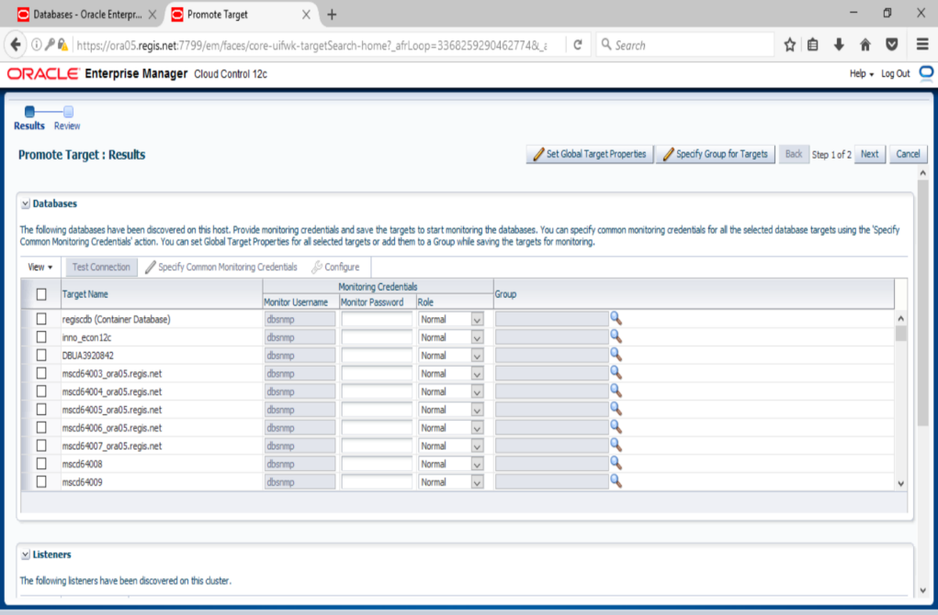

The practicum team performed different parts of the OEM lab, through testing and familiarizing ourselves with the application. We found that OEM has the potential to be very helpful and can be used to immediately tell the statuses of databases, memory usage, availability, most used, as well as other database information. It can be critical for data intensive businesses to stay on top of their databases, and OEM can help them do that.

**Help Desk duties**

Each team member was assigned to the Help Desk three to four teams during the eight-week semester, rotating different people assigned each week. Each of the three members assigned for the week checked the help desk multiple times a day, dealing with various requests and issues.

The types of tickets received included:

* Citrix connection issues that we had Rick Cisneros allow access

# SQL Plus database issues where the database had shut down and needed to be start up again

# SQL Plus or SQL Developer issues where we tested and guided the user through the correct login process

**Creation of the databases**

Various databases were created for different classes in the semester. One of the static databases created was for the UG Database Management CIS445X40 (80131) class during 2017 Spring 8 Week 1 (16S8W1), taught by Professor N. Juwale.

The 21 Oracle DBs/users were created, tested and assigned to the class:

***12C DATABASE LOGIN INFORMATION***

***DB Username DB Password DB Connect String***

***cis445x40\_01 regis8w1 regisdb12c***

***cis445x40\_02 regis8w1 regisdb12c***

***cis445x40\_03 regis8w1 regisdb12c***

***cis445x40\_04 regis8w1 regisdb12c***

***cis445x40\_05 regis8w1 regisdb12c***

***cis445x40\_06 regis8w1 regisdb12c***

***cis445x40\_07 regis8w1 regisdb12c***

***cis445x40\_09 regis8w1 regisdb12c***

***cis445x40\_10 regis8w1 regisdb12c***

***cis445x40\_11 regis8w1 regisdb12c***

***cis445x40\_12 regis8w1 regisdb12c***

***cis445x40\_13 regis8w1 regisdb12c***

***cis445x40\_14 regis8w1 regisdb12c***

***cis445x40\_15 regis8w1 regisdb12c***

***cis445x40\_16 regis8w1 regisdb12c***

***cis445x40\_17 regis8w1 regisdb12c***

***cis445x40\_18 regis8w1 regisdb12c***

***cis445x40\_19 regis8w1 regisdb12c***

***cis445x40\_20 regis8w1 regisdb12c***

***cis445x40\_21 regis8w1 regisdb12c***

Another database created was the MSCD610X40- Database Concepts class taught by Professor B Wells

**User creation**

|  |  |  |
| --- | --- | --- |
| **DB Username** | **DB Password** | **DB Connect String** |
| mscd610x40\_01 | regis8w1 | regisdb12c |
| mscd610x40\_02 | regis8w1 | regisdb12c |
| mscd610x40\_03 | regis8w1 | regisdb12c |
| mscd610x40\_04 | regis8w1 | regisdb12c |
| mscd610x40\_05 | regis8w1 | regisdb12c |
| mscd610x40\_06 | regis8w1 | regisdb12c |
| mscd610x40\_07 | regis8w1 | regisdb12c |
| mscd610x40\_08 | regis8w1 | regisdb12c |
| mscd610x40\_09 | regis8w1 | regisdb12c |
| mscd610x40\_10 | regis8w1 | regisdb12c |

# Chapter 3 – Practicum II Tasks

**MVC Lab**

To start Practicum II, we worked on a MVC lab, which allowed us to use Visual Studio 2015 and SQL Server to create entity data objects, controllers, and views for it. We created a Time Tracking application with Create, Editing, Deleting, and Details options. We then modified these options to be more user-friendly and responsive.

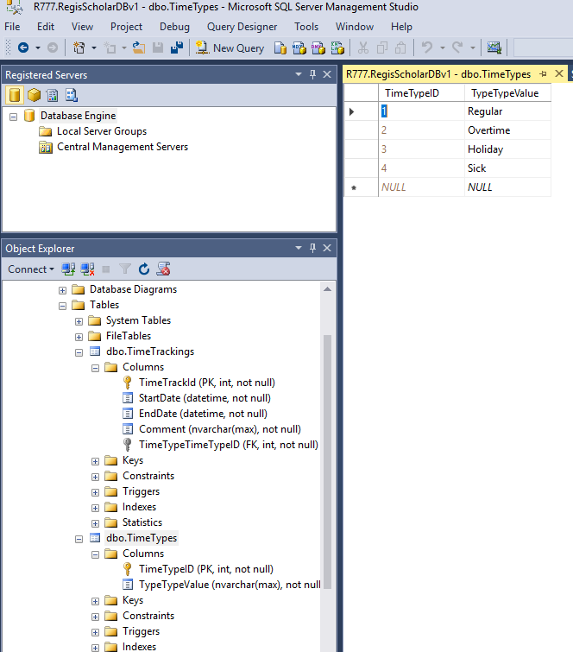

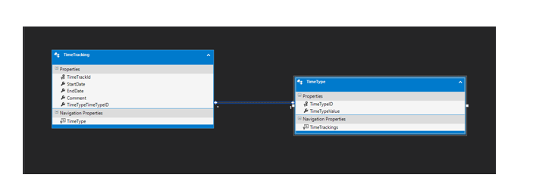

Creation

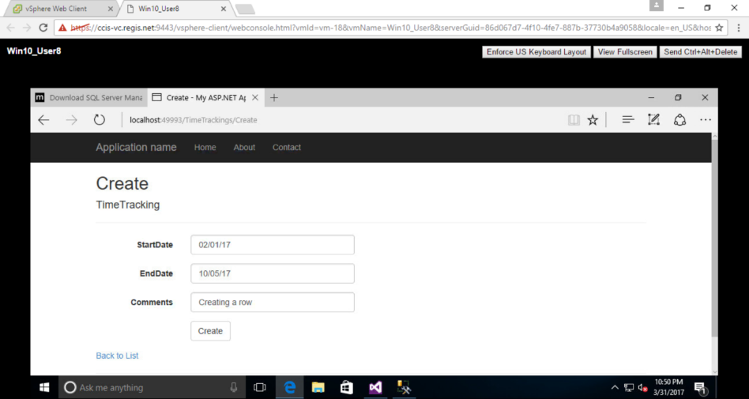

Date Picking Modification  
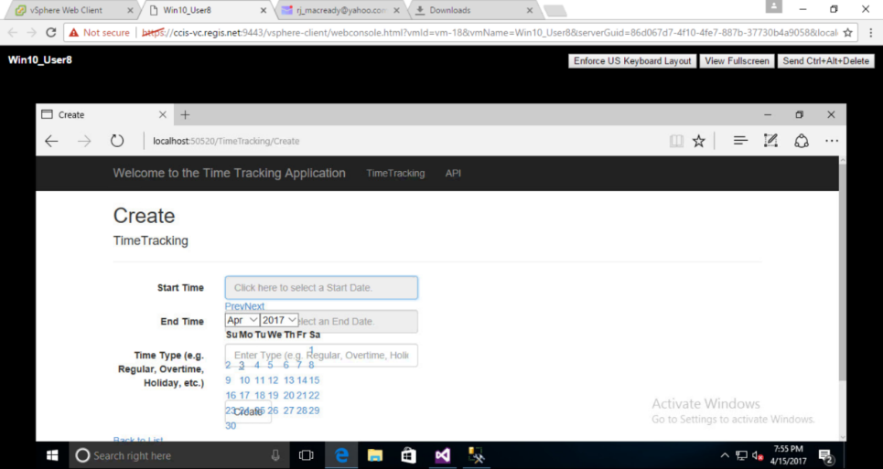

**Add Lookup Table**

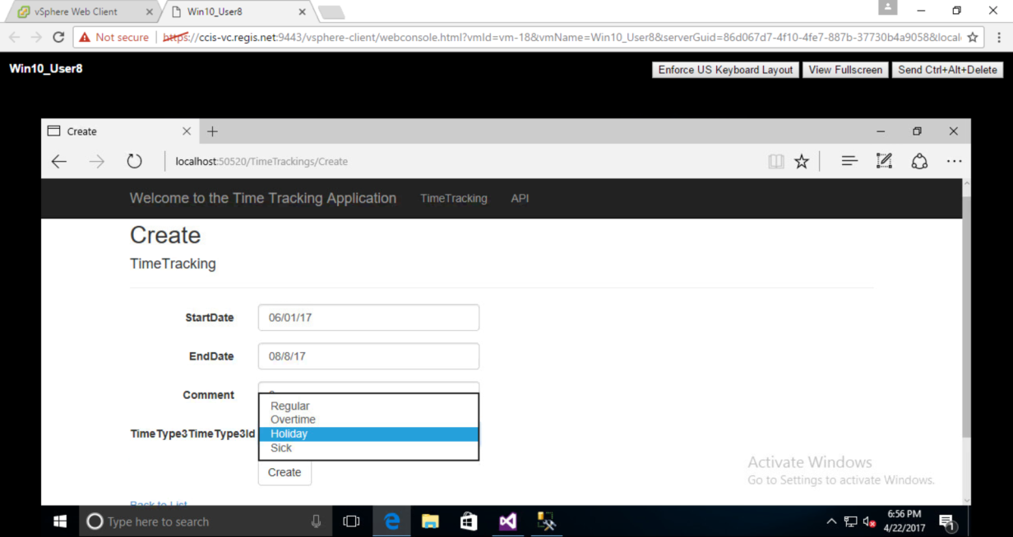

# Install MSCD640

The MSCD640 bin directory has been damaged or removed within the past year. One of the options we have is we can copy the MSCD644 directories over and rebuild the binaries. Tom looked at the directory structure to see what is missing, and performed a quick search for any backups. If we found a backup database, restoring from a backup was probably the safest and fastest way to restore this database.

After comparing the 644 and 640 directories, it was found that there are several directories missing. The 644 bin directory did in fact get copied to the 640 directory, but there appear to be many missing files to start 640. So we question whether we should shutdown 644 and copy the missing directories to 640 or just do a reinstall of MSCD640.

**Help Desk duties**

Just as in the first Practicum, each team member was assigned to the Help Desk three to four times during the eight-week semester, rotating different people assigned each week. Each of the three members assigned for the week checked the help desk multiple times a day, dealing with various requests and issues.

There were again tickets that included:

* Citrix connection issues that we had Rick Cisneros allow access

# SQL Plus database issues where the database had shut down and needed to be start up again

# SQL Plus or SQL Developer issues where we tested and guided the user through the correct login process

**Exploring the GITLAB  
RU-CCIS-DB-Practicum-Research-Database-Project-Fall-2016 project details**

We clicked and checked out the **Changes to Subcategory 3/12/2017** and saw the code changes

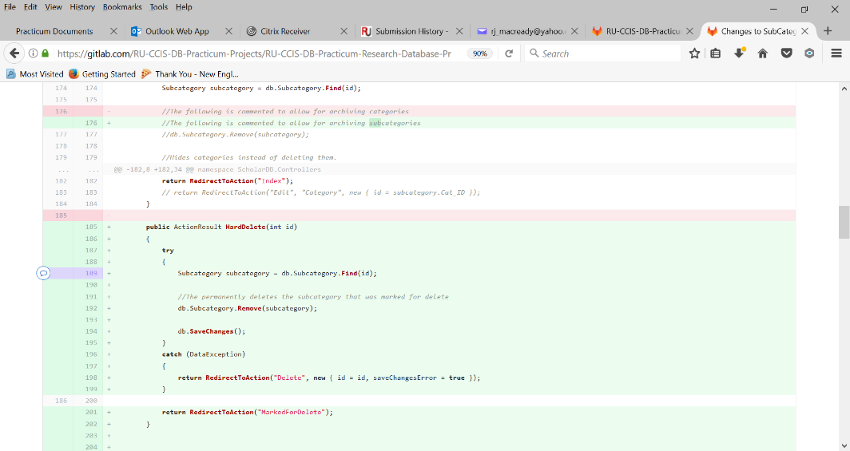

We tested cloning of the GITLAB Scholar DB URL and opened the solution

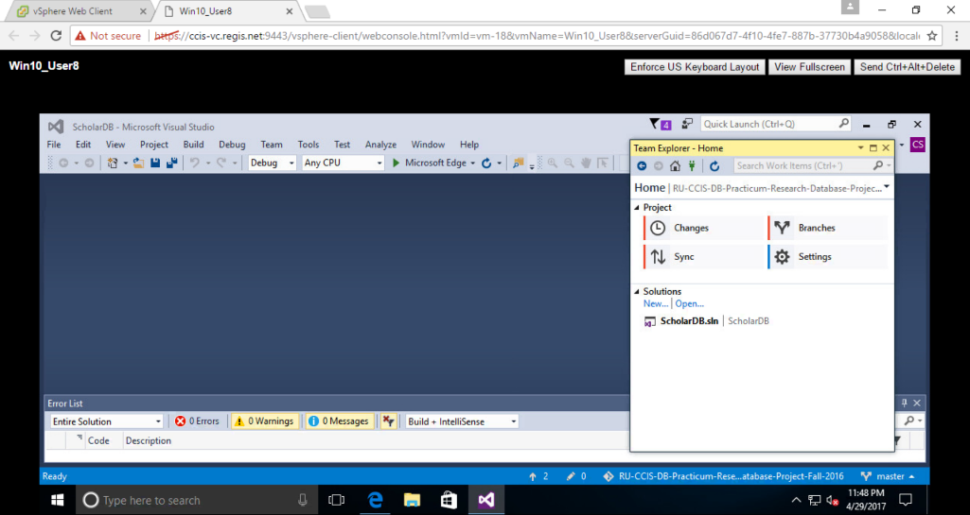

We did not make any changes, so we had no changes to Commit, Sync, and Push on Team Explorer.

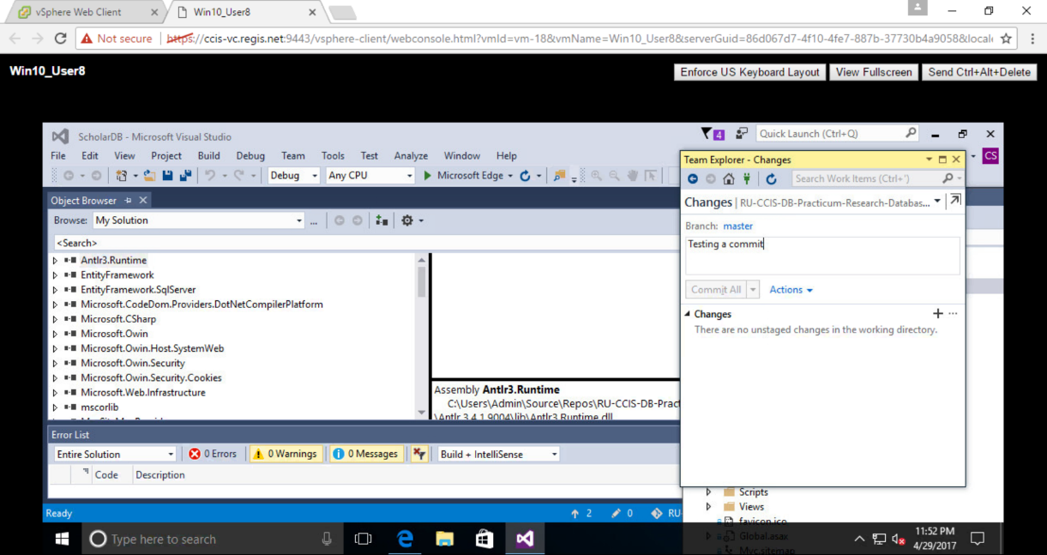

**Chapter 4 – Conclusion**

We started the Database Practicum I in January, and worked it for eight weeks, then went right into the Database Practicum II for eight weeks until May. Both Practicums introduced us to a variety of skills related to Oracle 12c database and user creation, Red Hat Linux bash scripting, agile database development using Oracle Apex and Visual Studio 2015+SQL Server, and real-time database monitoring via Oracle Enterprise Manager (OEM).

In the first Practicum, the team initially worked on a variety of Linux and Oracle Apex and OEM labs. After our PM checked Web Advisor to determine what databases needed to be created, we used Linux commands to navigate to the scripts directory, copy the script template, and edit the template using Vi. When the databases were created and permissions modified, instructions were provided to the Professors for each database created, along with the user IDs created.

We then experienced Apex labs, and these Apex labs introduced us to agile database development practices using SQL loader, Object browser and Master and Detail page creation wizards.

Apart from the labs, we had weekly meetings on Wednesday nights, and the occasional Saturday afternoon. Agendas and meeting minutes were documented for these meetings by the PM, and tasks were assigned to various team members, including the help desk schedule for the week.

Towards the end of Practicum I, maintenance work on the **ora05.regis.net** server was performed, and Jimmy was able to clear tnsnames.ora and listener.ora files for the obsolete databases. The result was a much more streamlined splash screen on the server welcome page.

The second Practicum had us performing labs on Visual Studio 2015 using MVC pattern applications that allowed us to create entity data objects in SQL server, and link those to scaffolding views and controllers. More databases were created with Linux in the same manner as was performed in the first Practicum, and the help desk continued to operate in the same rotating schedule.

Throughout both Practicums, everyone on the team worked well together, and we stayed in constant communication with each other through Skype. Overall, each member enjoyed working with other team members and learning from Professors throughout both Practicums. It was an overall positive experience for all involved.

**REFERENCES**

Kuhn, D. (2013). *Pro Oracle Database 12c Administration (Second Edition).* New York: Apress